**Test Environment Management Tools:**

* Environment Knowledge Base (CMDB)
* Test Environment Booking System
* Environment (Infrastructure) Orchestration Tool
* Build & Deployment Tools / Continuous Integration Tools
* Infrastructure Configuration Tools
* Service Virtualization
* Environment Shakedown Tools
* Service Support Tools (Incident & Change)
* Environment Health Dashboards
* Environment Knowledge Base (CMDB):

A configuration management database (CMDB) is a file -- usually, in the form of a standardized [database](https://searchsqlserver.techtarget.com/definition/database) -- that contains all relevant information about the hardware and software components used in an organization's IT (information technology) services and the relationships between those components. A CMDB provides an organized view of configuration data and a means of examining that data from any desired perspective.

* Environment (Infrastructure) Orchestration Tool:

1. [Kubernetes](https://kubernetes.io/)

It is an open-source platform that was originally designed by Google and now maintained by the Cloud Native Computing Foundation. Kubernetes supports both declarative configuration and automation. It can help to automate deployment, scaling, and management of containerized workload and services.

2. [Nomad](https://www.nomadproject.io/)

It is a simple, flexible, and easy-to-use workload orchestrator to deploy and manage containers and non-containerized applications across on-prem and clouds at scale. Nomad runs as a single binary with a small resource footprint (35MB) and is supported on macOS, Windows, and Linux.

* Build & Deployment Tools / Continuous Integration Tools:
  1. Jenkins

It is an open-source CI server for automating the build and testing processes. It is supported on Windows, Mac, and UNIX machines and is based in Java. Jenkins is widely customizable through its hundreds of plugins and supports distributed workloads across multiple machines to improve performance and deliver results faster.

* 1. CircleCI

It is a CI tool built to offer both flexibility and scalability to development teams. It focuses on performance through features such as parallel task execution to speed up building and testing applications. CircleCI offers an intuitive interface with customizable features and is available in both on-premise and cloud configurations.

* Infrastructure Configuration Tools

### ****1. Terraform****

[**Terraform**](https://www.terraform.io/) is one of the most popular IaC tools in the market. It's an open-source project with incredible flexibility, supporting all the most prominent cloud platforms, including;

* AWS
* GCP
* Azure

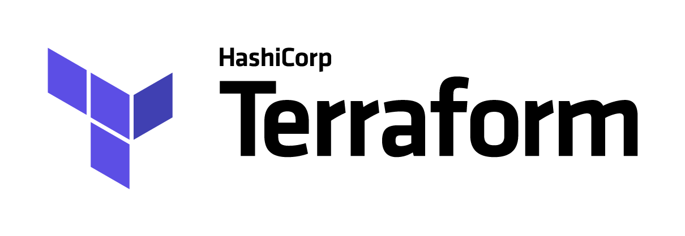

### ****2. AWS CloudFormation****

Like the all-rounder Terraform, [**AWS CloudFormation**](https://aws.amazon.com/cloudformation/) allows you to manage infrastructure and automate any deployments using code. The main difference comes down to how intimate CloudFormation is to AWS in that it only works with AWS IaC. However,  it makes up for this by being integrated with the entire platform.

